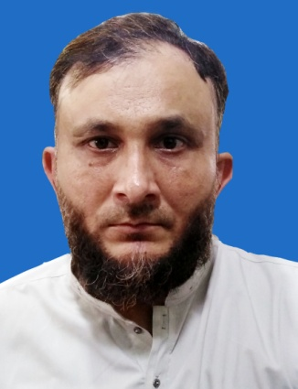
M . MUDASSAR AHMED
Address:
House No. 374C Street No. 18-A Phase 4-A Ghauri Town Islamabad .
Contact: 0092 343 6865173
Email: mudassirje@gmail.com

OBJECTIVE

Challenging and rewarding Logistic / Distribution Center Operations management position within the private sector where prior expericne, persona ability, and a commitment to professinalism would be of value. Position should allow for continued personal and professional growth commensurate with achievements.

PERSONAL INFORMATION
- Father name : Muhammad Hussain
- Date Of Birth : 08-08-1979
- CNIC No : 38403-216210-3
- Passport No : PF1152103
- Marital Status : Married
- Religion : Islam
- Nationality : Pakistani

ACADEMIC QUALIFICAITON

- Matric BISE SARGODHA
TECHNICAL QUALIFICATION

- B. Tech (Hons) Mechanical 2007-2010 Technical Board Karachi
- DAE (Mechanical) 1998-2001 Technical Board Lahore
- Electronic & Radio 1995 Technical Board Lahore
- H.V.A.C 2011 Technical Board Karachi

JOB EXPERIENCE

( from 7 Dec, 2015 to 2018) Working in OLYMPIA CHEMICAL LTED KHOUSAB as Supevisor Maintenance of Compressor Shop.
- Maintenance Of Screw Compressss 290 M3/min
- Maintenance of reciprocating Copressor 42 M3/min
- Making reports all parameters of screw compressor
- Use vibration meter & make reports
- Daily make shop activity like preventive mentaince
( from May 05, 2012 to May 5 2015) working in Solb Steel Company JAZAN Saudi Arab as Supervisor Rolling Mill Shop.
- Working with SMS Group (Italy) on Conveyour
- Belt alignment and dust collecting system commissioning & E.A.F & L.F Commissioning.
- Workign in electromegnatic roller assembled & dis assembled .
- Workig on different gear Box commissioning of gears asembled of super gear of dis assembeled,
- Workign on vertical cylinder like hydro test and maintenance .
- Know about of different wps.
- During shutdown workign on C.C.M like billet pusher assembeled and disassembled.
- Working on diffferent heat treatment.

(from April 3, 2009 to 12 June 2011) Working in GULF HEAVY INDUSTRIES JUBAIL SAUDI ARABIA as
PRODUCTION ENGINEER.
- Supervise of Pressure Vessels, Reactors, Columns, Drums, Deaerators and Skids with Piping etc.
- Heat Exhanger (Shell and Tube) & Waste Heat Boilers (ASME Sec.1), Chilklers, Condensers and Evaporators.
- Hea Treatment of equipment
Feb 2002 to 2009PEPOLES STEEL MILLS LTD. KARACHI (Manufacturer of Alloy and Special Steel)
- Maintenance Of Screw Compressss 290 M3/min

Executive (Mechanical)
- Production Supervisoion in Forging Shop. Operate & Supervise of 1700 ton forging press production in Forging Shop & Design Dies of varous forging products, Operate 80 M.T Reheating furnace Workign on cold drawing machanie &.
- Operate 15M. T Electric are furnace, etc.
- Supervise Machining Process of Dies. Supervison of Machining Process of Forging Dies inside outside PSM and Prepare it accurate as per drawing.
- DailyShop Activity Reports (DSAR). Prepare DSAR to show daily production and also pr epare monthly matrial balancing reports and feed it in system.

COMPUTER SKILLS
- Basic Computer skills (MS Word, Excel, Power Point and Internet etc)

LANGUAGES
- Urdu
- English
- Punjabi

REFERENCE
- Will be furnished on demand.

